Registration# Office Use Only

INSTRUCTIONS ON REVERSE!

Racking Horse Breeders’ Association of America
67 Horse Center Rd.● Suite B ● Decatur, AL. 35603 ● (256) 353-7225
RHBAA REGISTRATION APPLICATION
www.rackinghorse.com info@rackinghorse.com

BREEDING INFORMATION:
5A State Foaled in

Foaling Date

Breeding Date

If pasture bred, enter dates mare was exposed:
From: ______/______/______ To: ______/______/_______

5

COLOR: *Indicate basic body color of a roan, overo, sabino, tobiano, etc.
Photos showing both sides, front and back are required for any horse with a pattern (overo, sabino, tobiano, etc.)

6

□ Black

□ Smoky Black

□ Smoky Cream

□ Classic

□ Champagne

□ Classic Cream
Champagne

□ Bay

□ Brown

□ Buckskin

□ Perlino

□ Amber Champagne

□ Amber Cream
Champagne

□ Chestnut

□ Sorrel

□ Palomino

□ Cremello

□ Gold Champagne

□ Gold Cream
Champagne

□ White

□ Dunn

□ Grey

□ Silver

□ Roan

Mane/ Tail Color
__________________
__________________

PATTERN: * Must Mark Basic Color (Not White)
□ Overo □ Tobiano/ Sabino

□ Sabino □ Tovero

□ Tobiano □ Maximum White Sabino

8

LEG MARKINGS:
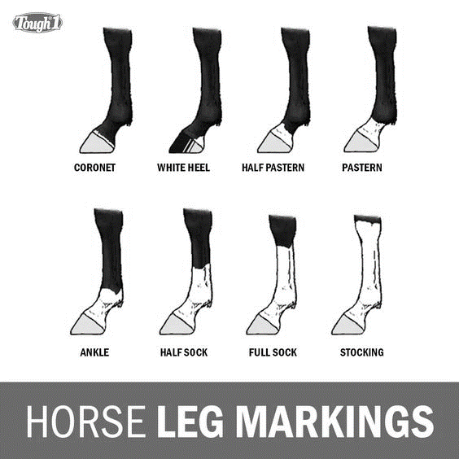
(1) Left Fore Leg: ____________________________
(2) Right Fore Leg: ___________________________
(3) Left Hind Leg: ____________________________
(4) Right Hind Leg: ___________________________

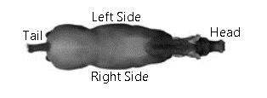
8A SCARS/ UNUSUAL MARKS:

____________________________________________________
____________________________________________________
____________________________________________________

7

FACE MARKINGS:

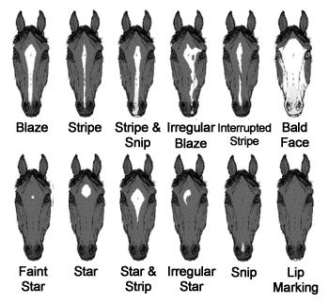
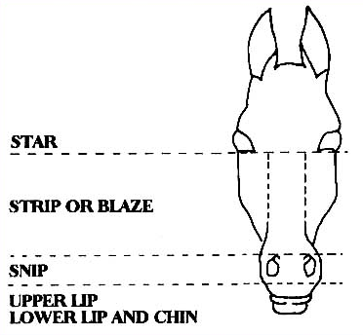

Draw in every white area. Indicate all dark spots within white area.
Including Upper Lip, Lower Lip, and Chin.
FEE SCHEDULE:

Registration Fee _______________________
DNA Fee ____________________________
Membership__________________________
Other _______________________________
Total Enclosed ________________________
1
SEX:

□ Stallion □ Mare □ Gelding

4

SIRE AND DAM: (If Pedigree or One Sided Pedigree Registering This Horse)

______________________________________________________________ ___________________________________
Sire’s RHBAA Registered Name Sire’s RHBAA Registration #

______________________________________________________________ ___________________________________
Dam’s RHBAA Registered Name Dam’s RHBAA Registration #

SIRE AND DAM OWNER INFORMATION: (If Pedigree or One Sided Pedigree Registering This Horse)

Sire’s Owner: X __________________________________________________________AT TIME OF SERVICE, SIGNATURE REQUIRED.

Dam’s Owner: (PRINT NAME) ________________________________________________________________AT TIME OF SERVICE.

Dam’s Owner: X ___________________________________________________________AT FOALING TIME, SIGNATURE REQUIRED.
Printed Name: ______________________________________ Email Address: ____________________________________
Mailing Address: _______________________________________ Cell Phone (______) ________-___________________
City / State/ Zip: ________________________________________ Home Telephone (______) _______-______________

REGISTRATION BY QUALIFICATION:

COMMISSIONER APPROVAL
Name (Print) _____________________
Signature _______________________
Commissioner # ____________________
Phone (_____) _______-___________
Date _________________________
(Application must be received in RHBAA Office within 5 Days)

9

□ And □ Or
Describe Facial Markings
____________________________________________________________
11

10

12

OWNER/APPLICANT INFORMATION:

I hereby certify that all information on this registration application and/ or parentage verification kit request is true and correct to my personal knowledge and agree that the association has the right to correct and or cancel the registration certificate for cause under its rules and regulations.
SOLE OWNER MUST BE 18 YEARS OF AGE

□ Joint Owner(s)
(Please Print)
Name
________________________________________
Address
Street
________________________________________
City
________________________________________
State______________ Zip ________________
Phone (______) _________-_______________
Member # _____________________________
Signature ______________________________
□ Sole Owner
(Please Print)
Name
________________________________________
Address
Street
________________________________________
City
________________________________________
State______________ Zip ________________
Phone (______) _________-_______________
Member # ____________________________
Signature _____________________________

2

2A

□RHBAA Pedigree Registration Application with DNA Included

□One Sided Pedigree with DNA Included

□Commission Registration with DNA included (Must be signed & Dated by RHBAA Commissioner)
Outside Association’s Name Registration #
_______________________ ____________
_______________________ ____________
_______________________ ____________

NAME CHOICES OF ANIMAL TO BE REGISTERED: (List 3 choices; 25 character maximum)

First Choice

Second Choice

Third Choice

Office Use

3

8A
SCARS, UNUSUAL MARKS: In Block # 8A, give written description of any scars or unusual marks, for identification purposes only.

FEE SCHEDULE
(Effective January 27, 2023)

Individual Membership $35.00
Family Membership $45.00
(Family includes 2 adults and 2 Juveniles)
(Membership expires December 31st each year.)

LATE FEE of $10 AFTER MARCH 15

REGISTRATION OF FOALS
Member Non-Member
Within 6 Months of Foaling $30.00 $60.00
After 6 Months
But Within 12 Months $40.00 $80.00
After 12 Months
But Within 24 Months $80.00 $160.00
After 24 Months
But Within 36 Months $160.00 $320.00
After 36 Months $200.00 $400.00
(Membership entitles you to one free pedigree foal registration, during year foaled, each year dues paid)

ONE SIDED PEDIGREE REGISTRATION
Member Non-Member
One Sided Pedigree registration $125.00 $250.00

PERFORMANCE REGISTRATION
Member Non-Member
Commission Registration $60.00 $120.00

TRANSFER OF TITLE
Member Non-Member
Within 30 Days $25.00 $50.00
From Date of Purchase
After 30 Days $30.00 $60.00
But Within 120 Days
After 120 Days $60.00 $120.00
But Within 180 Days
After 6 Months From $100.00 $200.00
Date of Purchase
OTHER SERVICES
Member Non-Member
DNA KIT $50.00 $100.00
Duplicate Certificate $35.00 $70.00
Of Registration
Alteration of Certificate $15.00 $30.00
Name Change $35.00 $70.00
(Name of Horse may be changed provided it has not sired or produced any RHBAA registered offspring.)
STALLION REPORTS
Penalty: Late Filing Fee
Member Non-Member
After October 15th $50.00 $100.00
Add a Mare to an $10.00
Existing Stallion Report
(A Recently Commissioned Registered Stallion Has 60 Days From Issue Date To File A Stallion Report Without Penalty.
A Recently Commissioned Registered Mare Has 60 Days From Issue Date To Add Mare To Stallion Report Without Penalty.)

INSTRUCTIONS
1
FEE SCHEDULE: Consult the fee schedule at the right and enter appropriate fees in Block #1 If you are using a Free Foal, write Free in the registration fee blank in Block # 1, other fees still due

2
This form may be used for, the following please select which and mark selection in Block #2
●Registration of foal with, pedigree on both sides (Both parents are RHBAA Registered) DNA Included
●1 sided Pedigree Registration (When only 1 parent is RHBAA Registered) DNA Included
●Commission Registration (Must be completed, signed & dated by a licensed RHBAA Commissioner) DNA Included

NAME: Provide three (3) name choices in Block #3. Names are limited to 25 characters (apostrophe’s and spaces count as a character)
Please do not use the Office use line.
3
4
SEX: In Block #4, indicate whether the animal to be registered as Stallion, Mare or Gelding.
5
BREEDING INFORMATION: In Block #5 enter the date the horse to be registered was born and dam of horse to be registered was serviced by stallion.
6
COLOR: Choose one base body color. Then choose a pattern as applicable. If the animal is overo, sabino, tobiano, tobiano/ sabino, tovero, or maximum sabino, you must submit photographs showing front, back, and both sides of the animal. The Application will be returned if this area is not completed. This will cause a delay in processing your application. For Example: Base body color- Black, Pattern- Sabino. May be applicable depending on animal.
5A
Indication of the state in which foal is born will allow records to be kept that could be used in states where awards are available through agricultural agencies.
7
FACE MARKINGS: Outline, with dark solid lines, all white on face lips and chin. Indicate dark spots within white areas. Give written description as blaze, strip, star, snip, bald, etc. If there are no markings, write none in the description.
8
LEG MARKINGS: In Block #8 list leg marking. Right side and left side, are determined as you are looking at the horse from behind.
9
REGISTRATION BY QUALIFICATION: Persons desiring to qualify a horse by performance, must submit to a licensed Commissioner of the RHBAA. Upon inspection, the Commissioner shall complete this section.
10
SIRE AND DAM: If Pedigree or one sided pedigree registering this horse enter the proper registered names and numbers of the sire and/or dam.
11
SIRE AND DAM OWNER INFORMATION: In Block #11 obtain signatures of stallion owner at time of service and mare owner at time of foaling. Transfers are required with the application for registration of foals when someone other than the owner of the foal owns the dam.
12
OWNER INFORMATION: In Block #12
Choose “Sole Owner” or “Joint Owner(s)” (Sole Owner must be at least 18 years of age) If Choosing “Joint Owner(s)”, also choose “And” or “Or”. When choosing “And”, this means no Joint Owner can act independently to change any information regarding this horse. When choosing “Or” this means any owner can act independently when changing any information regarding this horse. For Example: When selling a horse that has multiple owners Jane Doe AND John Doe must sign the transfer, or, Jane Doe OR John Doe can sign the transfer. Print Name, Address, phone number, and RHBAA Member #.
OWNER(S) SIGNATURE REQUIRED
REGISTRATION REQUIREMENTS
Pedigree

1. Stallion Reports are REQUIRED
2. Any foal born in 1994, or after, must be DNA typed for parentage verification. Sire and dam will also have to be DNA typed. Should the horse(s) have DNA typed previously, with TWHBEA, the owner will need to complete a Blood Type/ DNA Verification Affidavit. A copy of the DNA results and the verification must be filed with the RHBAA.
3. The horse must be the progeny of a registered Racking Stallion and a Registered Racking Mare
4. Block # 10 & 11 are REQUIRED to be completed entirely in ink, before the application can be processed.
5. Transfers are required with the application for registration of foals when someone other than the owner of the foal owns the dam at the time the application for registration is submitted. Transfers must be attached to such applications, date of purchase required, and fee paid for both registration and transfer.
REGISTRATION REQUIREMENTS BY QUALIFICATION
Commissioned Registration
1. (Examination) Horses meeting the performance qualifications must be personally inspected and approved by a qualified commissioner designated by the RHBAA to determine that the horse performs the “rack” as defined in the Bylaws.
2. All horse foaled January 1, 1994 or after must be DNA typed in accordance with the requirements of the RHBAA in order to be qualified for registration.
3. If a horse is being Commission Registered with RHBAA and has already had DNA completed by TWHBEA, we will accept this DNA due to an agreement with TWHBEA. In addition to the RHBAA Registration Application, you must provide us a copy of the front and back of the horse’s TWHBEA registration papers. You also must complete the RHBAA “Blood Type/DNA Verification Affidavit”

REGISTRATION REQUIREMENTS
One Sided Pedigree
1. Stallion Report is not required. The signature of the Stallion (at time of service) or the signature of the Dam (at foaling time) is REQUIRED. The signature of the registered RHBAA parent acts in lien of a Stallion Report.
2. Block # 10 & 11 complete the fields for the RHBAA registered parent, leaving the fields of the unregistered parent blank. The signature of the owner (sire, at time of service or dam, at time of foaling) of the RHBAA registered parent is required.
3. Any foal born in 1994, or after, must be DNA typed for parentage verification. The RHBAA registered sire or dam must be DNA typed.
4. The horse must be the progeny of a registered RHBAA Stallion or a registered RHBAA Mare. Upon receiving a Certificate of Registration for the horse being registered, RHBAA does not make claims that the horse being registered possesses breed standards, the certificate solely verifies the parentage of the one sided pedigree.

PLEASE REVIEW THIS APPLICATION CAREFULLY BEFORE MAILING TO THE RHBAA OFFICE. BE SURE YOU HAVE PROPER DATES, MARKINGS, SIGNATURES, ETC.
INCORRECT OR INCOMPLETE APPLICATIONS WILL BE RETURNED.
2A
List any outside associations this horse is currently registered with and its registration number with that association. (Must provide a copy of front and back of those papers for cross reference purposes only)
GENERAL INFO
*It is necessary that the RHBAA be notified when a stallion is gelded, and given date of the gelding.
*The name of any registered Racking Horse can be changed, upon payment of fee, provided it has not sired or produced any RHBAA registered offspring.

*CERTIFICATES OBTAINED BY FRAUD OR MISREPRESENTATION WILL BE CANCELED, AND ALL FUTURE CERTIFICATES WILL BE DENIED TO THE OFFENDING PARTY.

