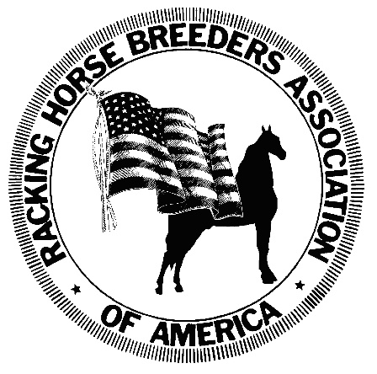
RHBAA Membership Application

Individual Membership $35 ($45 after March 15th)
Family Membership $45 ($55 after March 15th) includes 2 adults & 2 children
Membership Cards Expire December 31st of each year.

We encourage all persons who are actively involved with the Racking Horse to become members. Your involvement in the RHBAA is important and we encourage you to join in making us strong and unified. Mail your application with a check or money order to:
RHBAA, 67 Horse Center Road, Ste. B, Decatur, AL 35603
Phone & Fax: 256-353-7225 Email: info@rackinghorse.com www.rackinghorse.com

AMOUNT ENCLOSED $ __________ Cash Check Money Order Visa /MasterCard
Check/Money Order # ____________ Credit Card # ______________________________________Exp. Date _________ CVC Code __________
Name on Card ___________________________________ *There will be a 3% surcharge added to all credit card payments.
……………………………………………………………………………………………………………
1. ___________________________________Membership # _________Birth Date ___________ SS# ________________
*Primary member, entitled to one (1) free pedigree registration, during the year foaled, each year membership dues are paid.
ADDRESS________________________________________________PHONE_____________________________________
CITY, STATE, ZIP ______________________________________________EMAIL _________________________________
2. ____________________________________Membership # ___________ Birth Date __________ SS# ______________
3. Juvenile _____________________________Membership # ___________Birth Date __________ SS#_______________
A Juvenile member must be under 18 years of age. Date of birth is mandatory for Juvenile Members.
4. Juvenile _____________________________Membership #___________ Birth Date __________SS#_______________
A Juvenile member must be under 18 years of age. Date of birth is mandatory for Juvenile Members.

Under the penalties of perjury, I certify that the above information is true and correct:

SIGNATURE OF PRIMARY APPLICANT REQUIRED __________________________________________________________________
Agrees to abide by the Rules and Regulations of the RHBAA. I am also entitled to conduct business with the RHBAA at reduced prices.
*This application cannot be changed or altered in any way once it has been submitted and accepted by the RHBAA.

