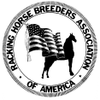
RACKING HORSE BREEDERS’ ASSOCIATION OF AMERICA
67 Horse Center Road Suite B ∙ Decatur, AL 35603
OFFICE & FAX (256) 353-7225
E-mail: info@rackinghorse.com
Website: www.rackinghorse.com

RHBAA AFFILIATION APPLICATION
NAME OF SHOW_____________________________________________________________________________________
DATE OF SHOW_____________________LOCATION__________________________STARTING TIME__________________ SPONSORING ORGANIZATION___________________________________________________________________________ CITY__________________________________ STATE___________________
WHAT CHARITY DOES THIS SHOW BENEFIT________________________________________________________________
___________________________________does hereby agree to abide by the rules and regulations of the Racking Horse Breeders’ Association of America, Decatur, Alabama. Said affiliation/sanction forms to be mailed within thirty (30) calendar days prior to the show.
Upon receipt of payment ($50.00) and affiliation application, permission will be granted to:
Judge(s): _____________________________________________________________________________ to serve in the official capacity of Judge(s) at your show.
Number of Padded Racking Horse Classes: _________ Number of Flat Shod Racking Horse Classes: __________ HIO Used ____________________________________________
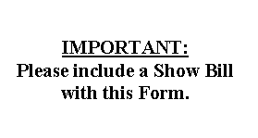
_____________________________________________________
Sponsoring Organization Contact Person

_____________________________________________________
Signature of Show Manager

_____________________________________________________
Address of Show Manager

_____________________________________________________
Phone Number of Show Manager

Note: Permission will not be granted to any RHBAA judge to officiate at any affiliated/sanctioned event until this form is signed and returned to the:
Racking Horse Breeders’ Association of America
67 Horse Center Road, Ste B · Decatur, AL 35603
Office and Fax (256) 353-7225
Your show package will be mailed to the Show Manager once the signed Affiliation/Sanction agreement is received by the RHBAA. Thank you and Best Wishes for a successful show.

